Introduction
MO’PITSENG MOBILE KITCHEN FOOD SERVICES WEBSITE PROPOSAL  MP WEBSITE VISUAL CODE | ST10519827  Karabo Modiyeyi Motsoeneng  WEDE5020 WEB DEVELOPMENT

  - My name is Karabo Motsoeneng and this document consists of the development of Mo’Pitseng mobile kitchen food services how it was discovered and what is our future and what is happening in the present. This is for learning purposes for other companies to also be interested in our business development. This for part 1 of the (POE) project proposal approval.
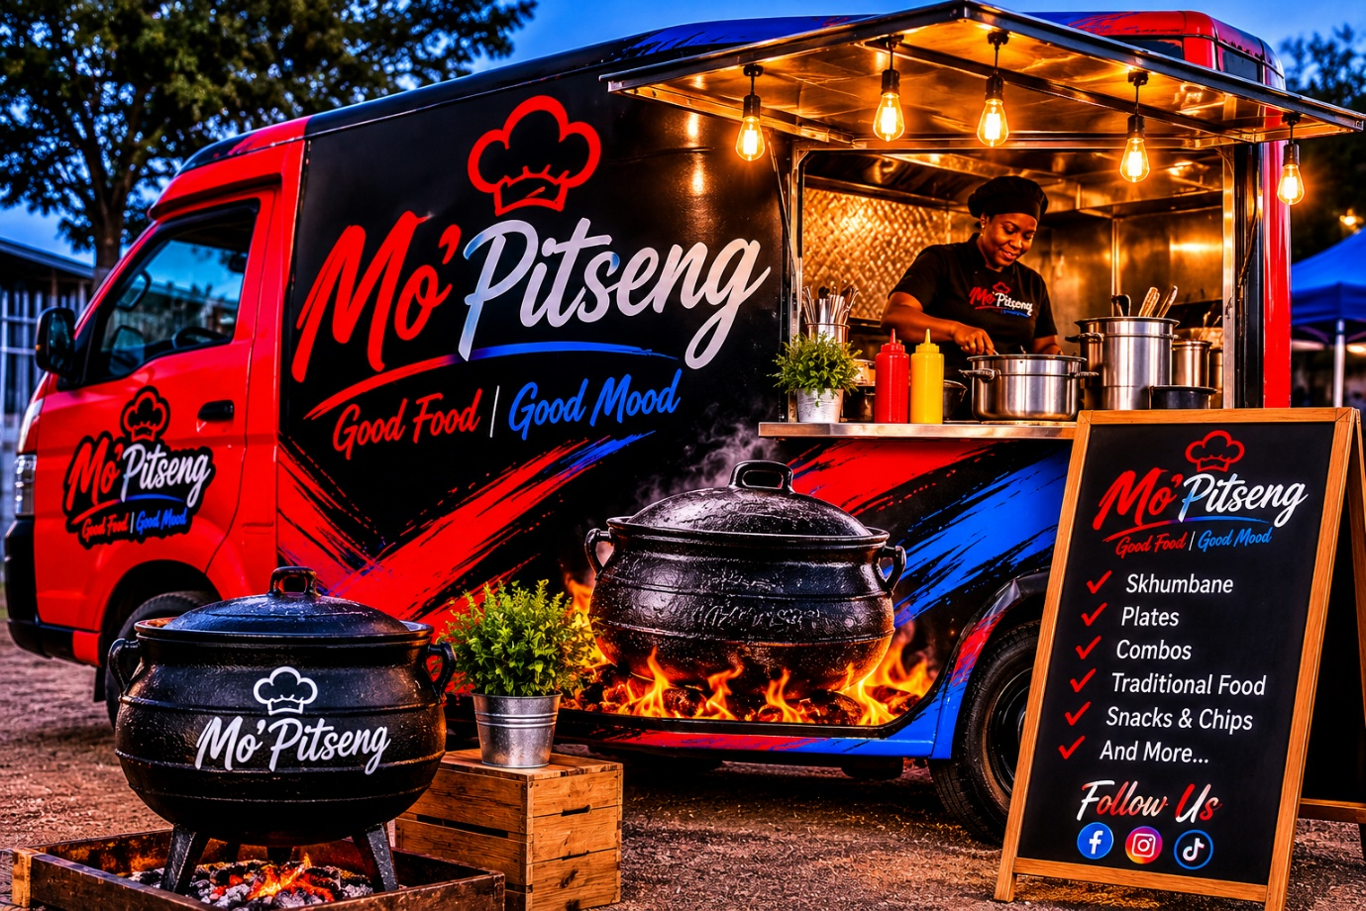Organisation overview

Name: Mo’Pitseng mobile kitchen food services

Brief History: Mo’Pitseng mobile kitchen food services was bought and started operating 2023 of November. It is a family business created by the owner Thabiso Motsoeneng in desperate need of a business empire for his family to help strive for his children and because of being a single parent a lot of things pressured him to think of his children.
Mo’Pitseng is a traditional saying “in the pot” meaning traditional slow-cooking methods over firewood. The inspiration of this kind of business comes from his own culture and the inviting of friends and family to his own house to host a small potjikoes dinner for everyone this brought joy over him and his inspiration was born out of passion for business and cooked food.
Expect the passion of traditional foods he also has discovered the new trend foods like vetkoesks(dibeko),bunny chows(skhumbane) and chips with every side dish that is to your comfort. This is for the affordability of people that have smaller salaries or for people who always have passion for what they call kasi junk food.
This business strives in black ethnicity, black culture and the taste of your own home.

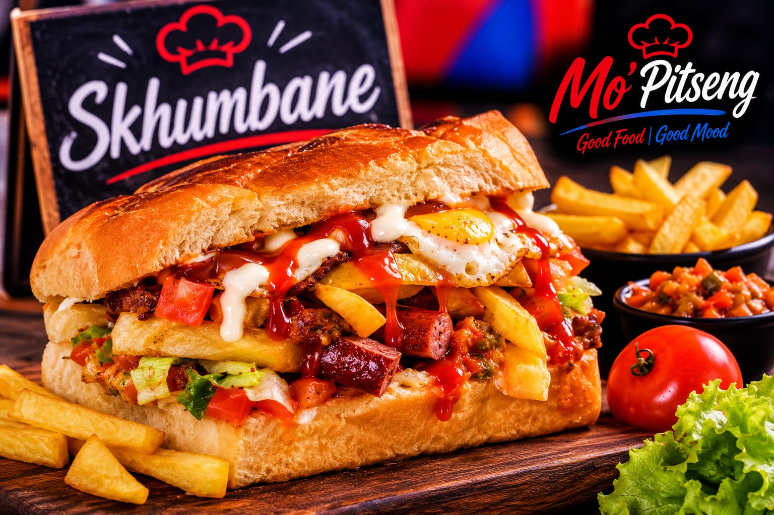
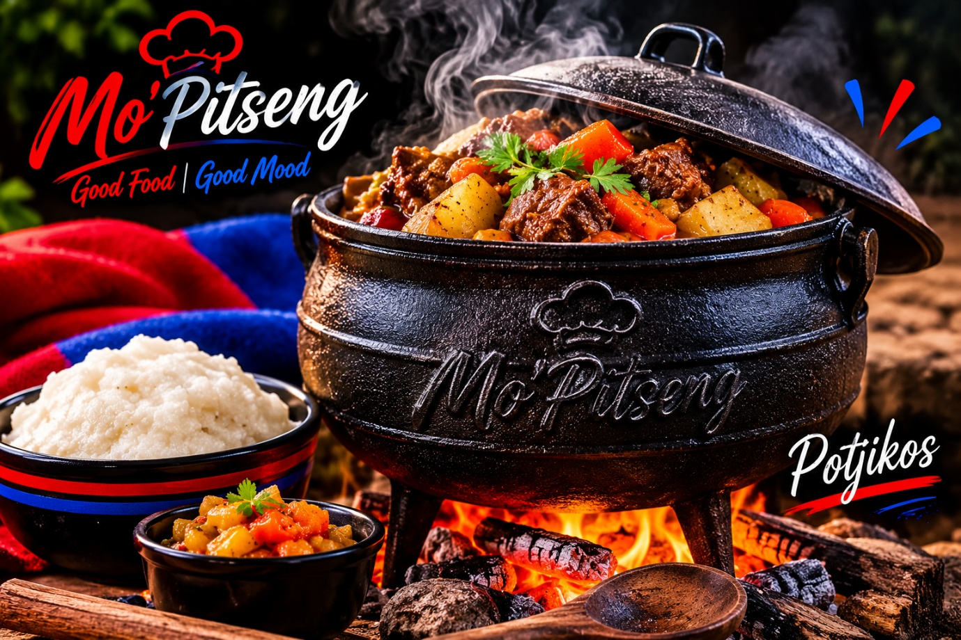
Goals and objectives

Mo’Pitseng is local mobile kitchen food services that aims to keep the tradition of black society food and the feeling of tasting home away from home foods. Phola park has always been a quiet area and there is a secondary school that sometimes struggle with food supplies. The mobile kitchen helps with food supplies as children are able to buy food that are affordable towards themselves.

KPIs
F
Financial: tracks money and the budget for expenses
Customer: how many customers buy per week
Operational: the speed of the cooks and the speed of customer arrivals.

Budget list

Fixed expenses:
cake flour
Oil
Baked bread
Archaar
Dried fish/snoek original
Dried fish/snoek garlic
Fali
Palony
Eggs
Total : 350 per finished product
Gas : R320 9kg
Total budget list: R670
Unfortunately for this kind of business there is no particular budget list because some products finish within a week or even 3 days because of that it is only used when all products have to bought .
Features and functionality
Html structure with menu.html, index.html, query.html ,aboutus.html
Css structure that will shape the website make it look good I went with a maroon style because of how aesthetic it looks with the colors of the theme for mobile kitchen

Design and user experience

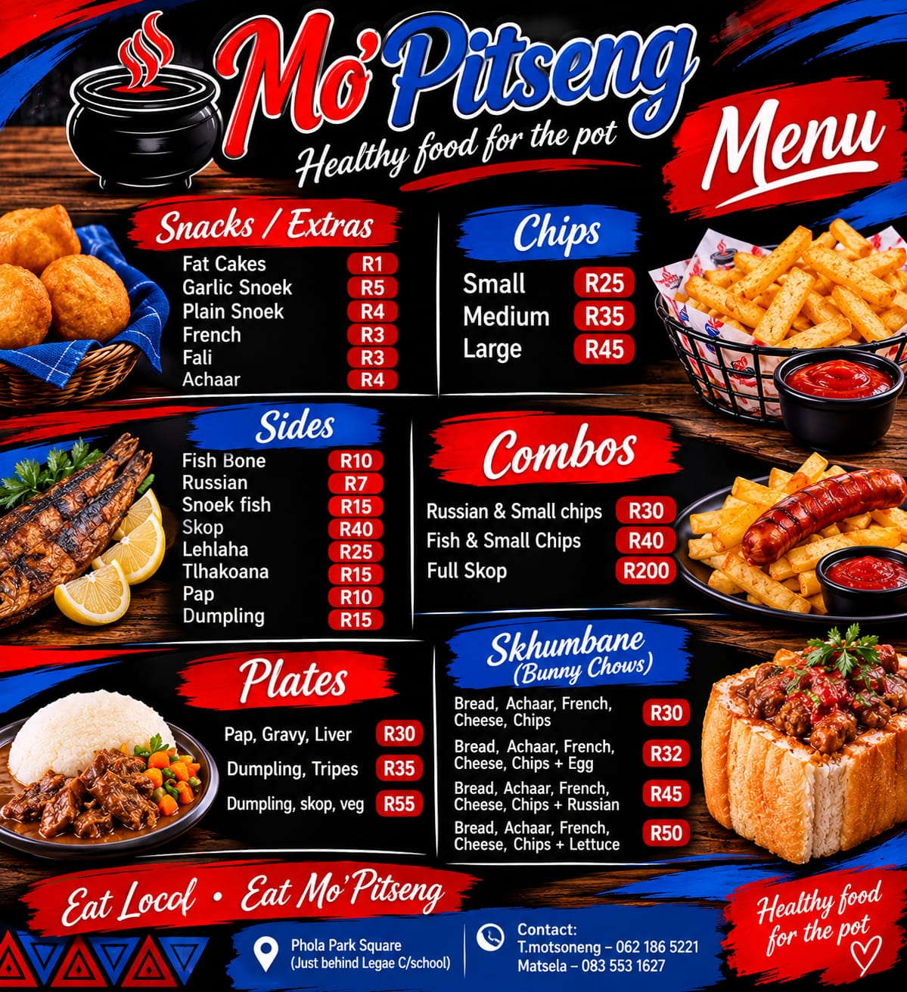

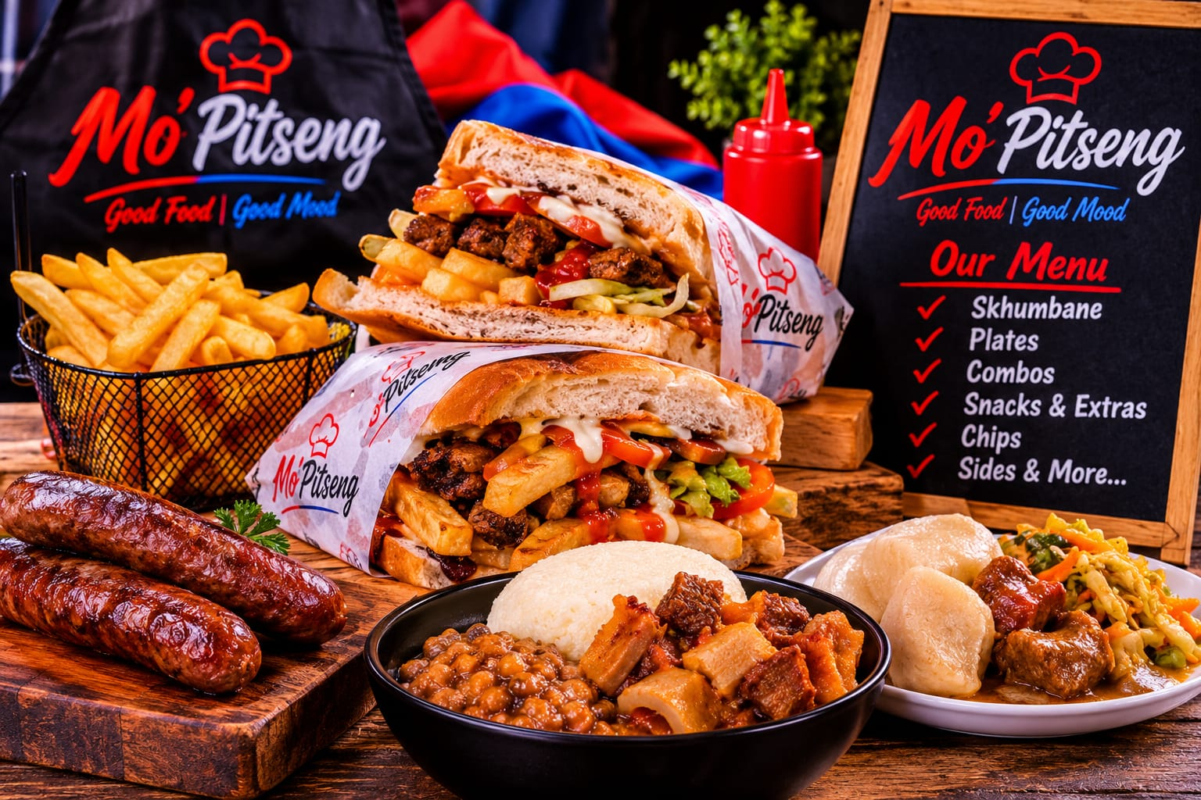

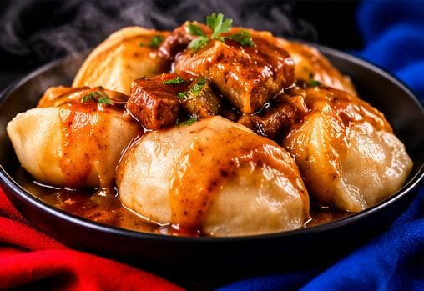
Skop
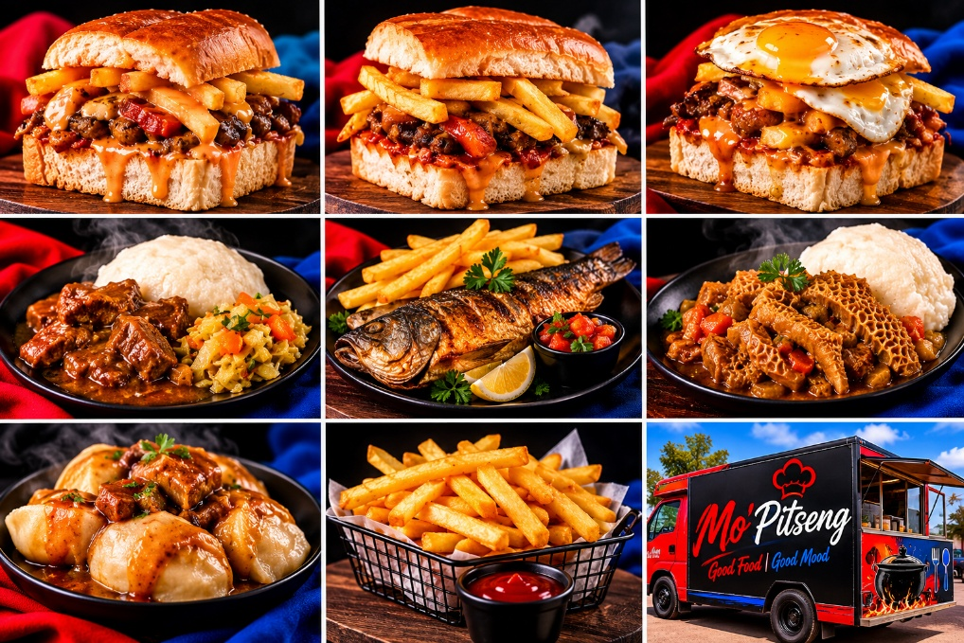

Timeline and milestone
August 13 2026 at 7:54 pm
August 13 2026 at 8:15 pm
August 14 2026 at 2:09 pm

New timeline
September 17,2026 at 7:34
September 17,2026 at10:30 finished and started working on proposal

New timeline
October 31, 2026, at 4:58 pm, 5:07pm, 10:30pm,
November 1, 2026, at 2:42pm, 4:06pm, 5:25pm
November 2, 2026, at 11:12am, 11:26am, 12:44pm

References

